Screenshots for **KafkaProj**

1. After running the producer file(KafkaProd.java) to send message

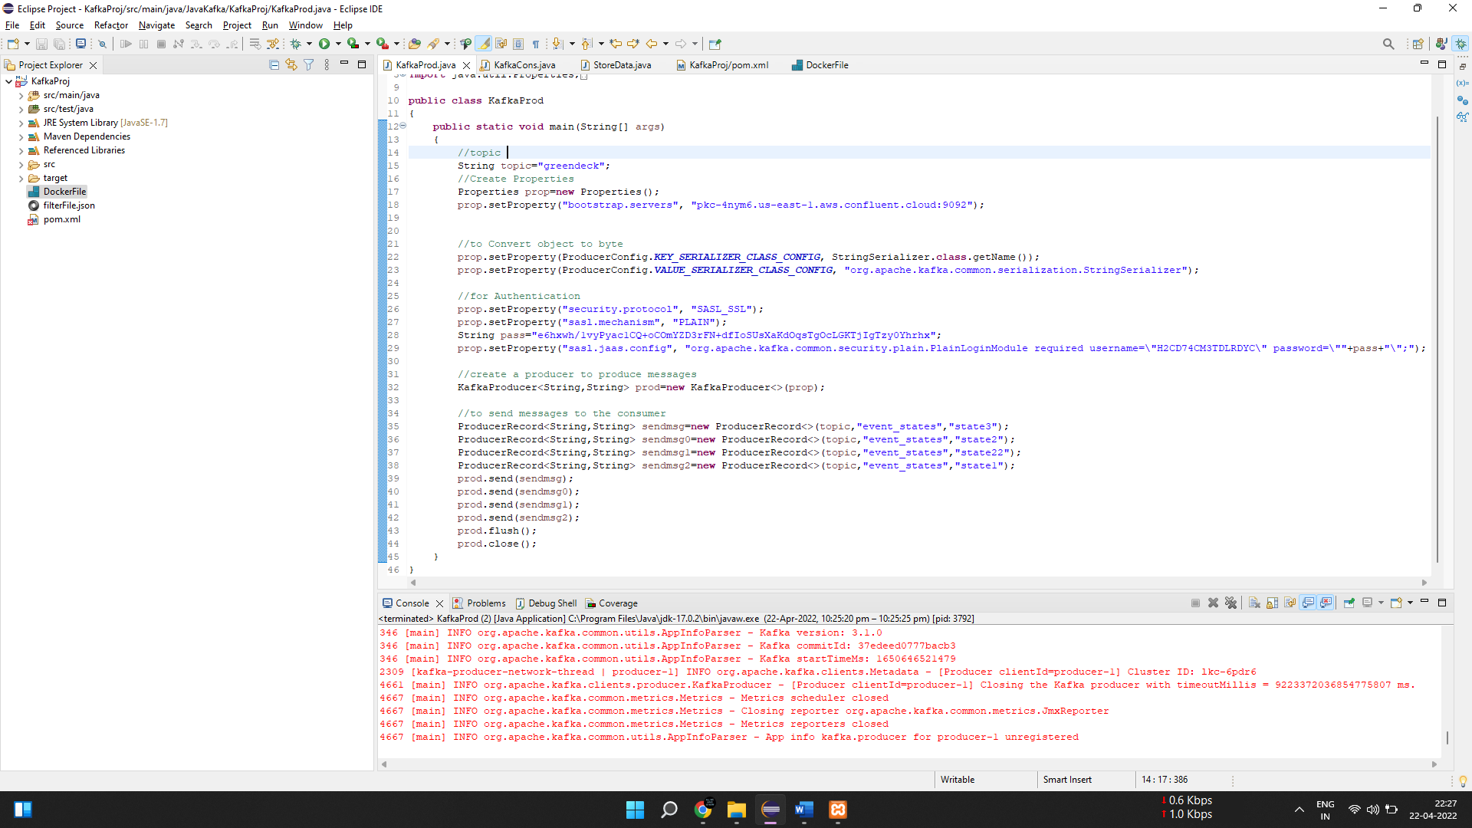

1. Before Running the Consumer File(KafkaCons.java).

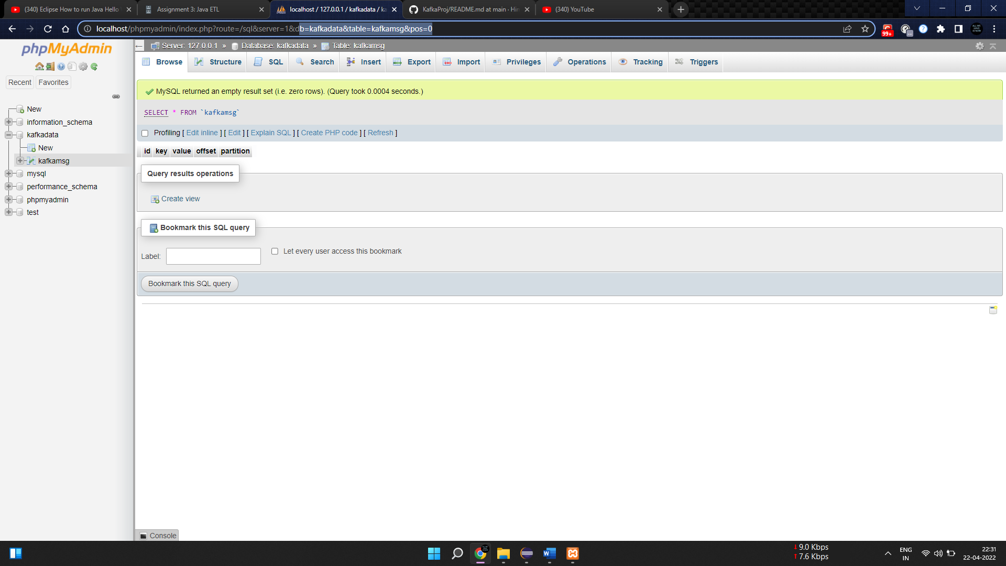

1. After running the consumer file(KafkaCons.java) to consume messages and filter records to store in mysql.

